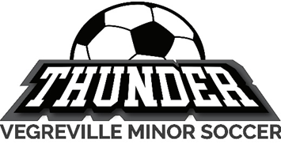

Code of Conduct to Protect Children

“Organization” refers to: _Vegreville Minor Soccer Association____

le**: Code of Conduct to Protect Children
Vegreville Minor Soccer Association has developed the following Child Protection Code of Conduct to guide our employees/volunteers in their interactions with children. The safety, rights, and well-being of children we serve are at the core of our daily programs. We nurture supportive relationships with children while balancing and encouraging appropriate boundaries.
Why a Child Protection Code of Conduct is important?
Our organization is committed to ensuring all children are protected and safe. A Code of Conduct to Protect Children is an important part of creating safe environments for children. The safety, rights and well-being of children participating in our programs is a priority in our daily operations.

The intent of the Code of Conduct to Protect Children is to guide our staff/volunteers in developing healthy relationships with the children involved in sport programs delivered by our organization and to model appropriate boundaries for children.
Treating Maintaining Boundaries
All staff/volunteers must:
- Treat all children with respect and dignity.
- Establish, respect, and maintain appropriate boundaries with all children and families involved in activities or programs delivered by the organization.
- It is important to monitor your own behavior towards children and pay close attention to the behavior of your peers to ensure that behavior is appropriate and respectful and will be perceived as such by others.

All your interactions and activities with children:
- should be known to, and approved by the board, where applicable, and the parents of the child
- tied to your duties , and
- designed to develop the child’s skills in the sport program.

Always consider the child’s reaction to any activities, conversations, behavior, or other interactions.
If at any time you are in doubt about the appropriateness of your own behavior or the behavior of others, you should discuss it with the designated person within your organization.

Examples of unacceptable behavior toward a child:
- embarrassing
- shaming
- blaming
- humiliating
- putting them down

Staff/volunteers of the organization must not:
- Engage in any sort of physical contact with a child that may make the child, or a reasonable observer feel uncomfortable, or that may be seen by a reasonable observer to be violating reasonable boundaries.
- Engage in any communication with a child within or outside of duties with the child, that may make the child uncomfortable or that may be seen by a reasonable observer to be violating reasonable boundaries.
- Engage in any behavior that goes against (or appears to go against) the organization’s mandate, policies, or Code of Conduct to Protect Children, regardless of whether they are serving the organization at that moment.
- Conduct their own investigation into allegations or suspicions of potentially illegal or inappropriate behavior – it is a staff/volunteer’s duty to report the matter to the designated person, Child Welfare Agency, or law enforcement, not to investigate.
What Constitutes
Inappropriate behavior includes:

1. Inappropriate Communication. Communication with a child or his/her family outside of the context of duties
for the organization, regardless of who initiated the exchange. Any communication with a minor must follow
the Rule of Two. For example:
- Personal phone calls not tied to duties with the child.
- Electronic communications (email, text message, instant message, online chats, social networking including “friending”, etc.) not tied to duties with the child.
- Personal letters not tied to duties with the child.
- Excessive communications (online or offline)

2. Inappropriate Contact. Spending unauthorized time with a child outside of designated duties with the
organization.

3. Favoritism. Singling out a child or certain children and providing special privileges and attention. (For example,
paying a lot of attention to, giving, or sending personalized gifts, or allowing privileges that are excessive,
unwarranted or inappropriate.)

4. Taking Personal Photos/Videos. Using a personal cell phone, camera, or video to take pictures of a child, or
allowing any other person to do so, as well as uploading or copying any pictures you may have taken of a child
to the Internet or any personal storage device. Pictures taken as part of your job duties are acceptable,
however, the pictures are to remain with the organization and not be used by you in a personal capacity.

5. Telling sexual jokes to a child or making comments to a child that are or is in any way suggestive, explicit, or
personal.

6. Showing a child material that is sexual in nature, including, signs, cartoons, graphic novels, calendars, literature,
photographs, screen savers, or displaying such material in plain view of a child, or making such material
available to a child

7. Intimidating or threatening a child

8. Making fun of a child

Inappropriate behavior will not be tolerated, especially as it relates to the well-being of the children involved in activities or programs delivered by the sport organization.

Whether or not a particular behavior or action constitutes inappropriate behavior will be a matter determined by the organization having regard to all of the circumstances, including past behavior, and allegations or suspicions related to such behavior.
Reporting Requirements
All staff and volunteers must report suspected child sexual abuse, inappropriate behavior or incidents that they become aware of, whether the behavior or incidents were personally witnessed or not.

Where to report:

1. All allegations or suspicions of potentially illegal behavior (for example, child sexual abuse) that a
staff/volunteer witnesses first-hand, must be promptly reported to police and/or child welfare.

2. To ensure the protection of all children in our care, all allegations, or suspicions of potentially illegal behavior
that a staff/volunteer learns of must also be promptly reported to police and/or child welfare. Police and/or
child welfare will make the determination as to whether the allegation or suspicion requires further
investigation.

3. All allegations or suspicions of inappropriate behavior (see above examples), that a staff/volunteer learns of
or witnesses first-hand, must be reported to the designate for the sport organization.

Keep in mind that you may learn of potentially illegal or inappropriate behavior through the child or some other third party, or you may witness it first-hand. Examples of the type of behavior you may learn of or witness and that you must report as set out above includes:
- Potentially Illegal behavior by a Staff/Volunteer of the organization
- Potential Illegal behavior by a third party, such as a Parent, Teacher, Babysitter, Coach

If you are not sure whether the issue you have witnessed or heard about involves potentially illegal behavior or inappropriate behavior, discuss the issue with the designated person within your organization who will support you through the process. Remember: You have an independent duty to report all suspicions of potentially illegal behavior directly to police and/or child welfare.
Follow up on Reporting
When an allegation or suspicion of potentially illegal behavior is reported, police and/or a child welfare agency will be notified. The sport organization will follow up internally as appropriate.

When an allegation or suspicion of inappropriate behavior is made, the sport organization will follow up on the matter to gather information about what happened and determine what, if any, formal or other disciplinary action is required.

In the case of inappropriate behavior, if:
- multiple behaviors were reported.
- inappropriate behavior is recurring, or
- the reported behavior is of serious concern the organization may refer the matter to child welfare agency or police.

See Appendix A for: Steps for Reporting Inappropriate Conduct for Coaches
Guide for Reporting Child Abuse and Misconduct for Parents
Guide for Adults Interaction with Children in Sport
Resources for Children

Appendix A
Steps for Reporting Inappropriate Conduct for Coaches
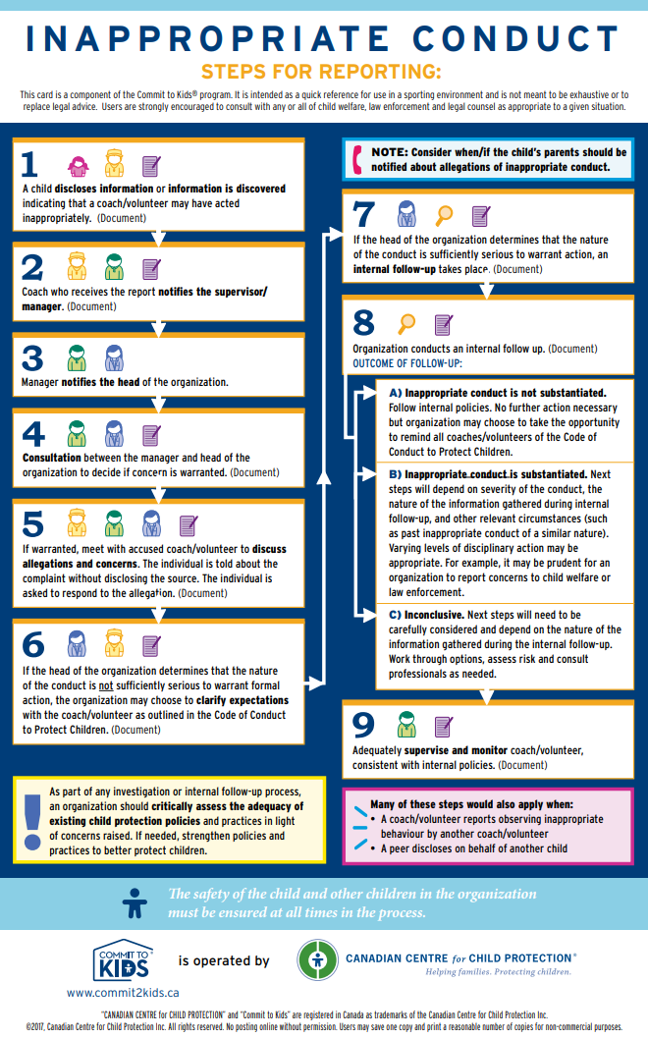
Guide for Reporting Child Abuse and Misconduct for Parents

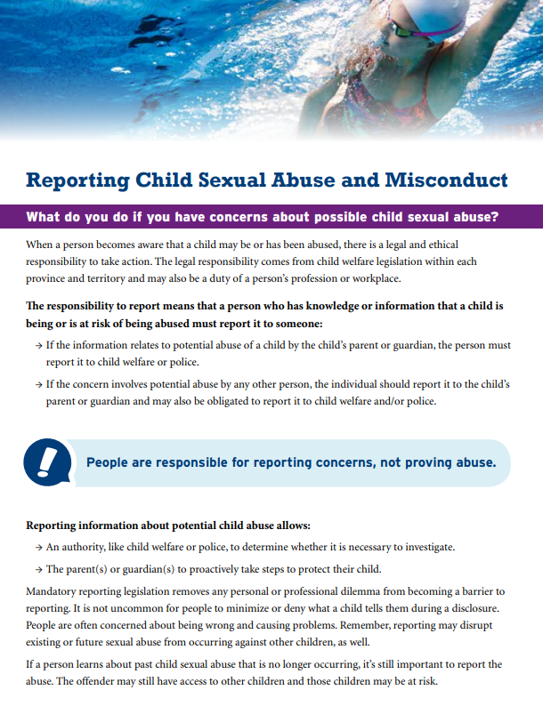
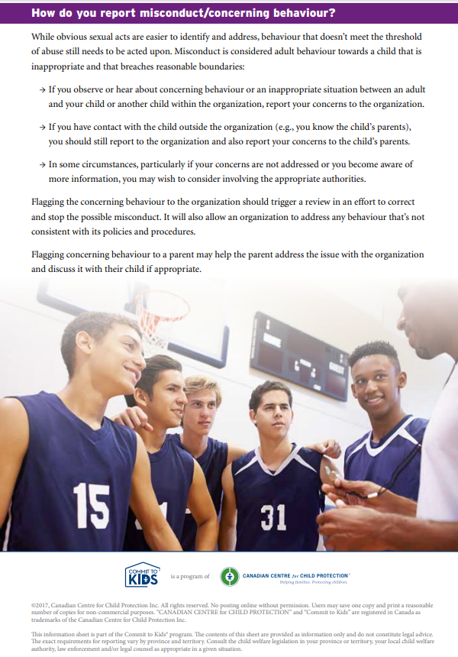
Guide for Adults Interaction with Children in Sport

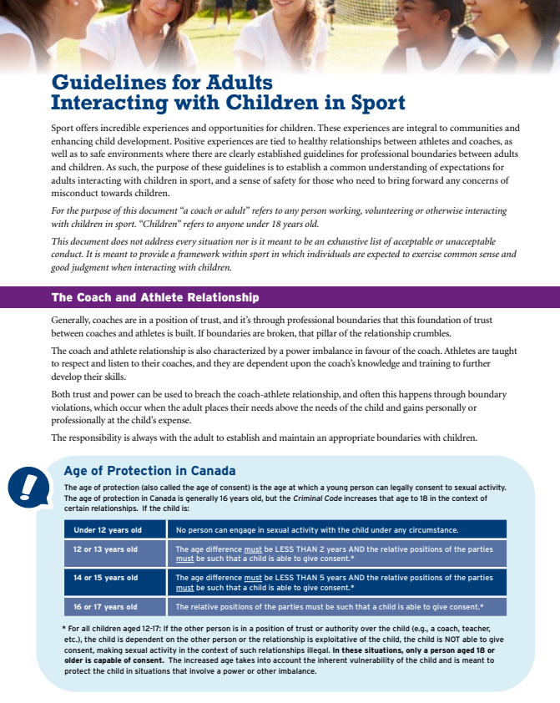
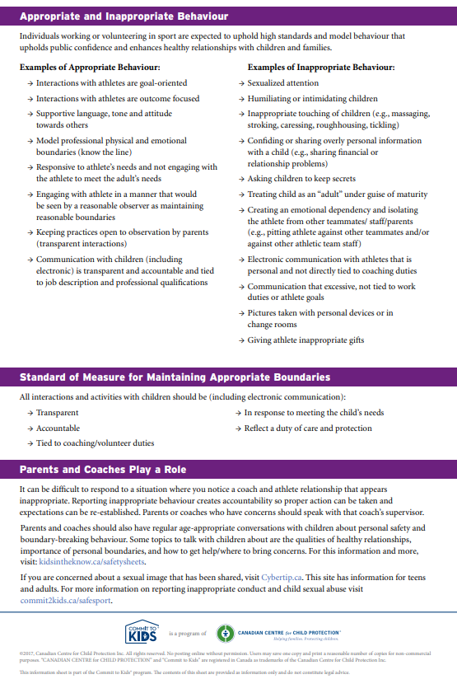
Resources for Children

Kids Help Phone:

Kids Help Phone is Canada’s only national 24–hour, bilingual and anonymous phone counselling, web counselling and referral service for children and youth. Their service is completely anonymous and confidential — they don’t trace calls or have call display. Callers don’t even have to tell they their name if they don’t want to.

Created in 1989 to provide a way for young people to confidentially report abuse, Kids Help Phone provides free, accessible support to any young person reaching out, anywhere in the country. Since its creation, Kids Help Phone has evolved their response and solutions, always focused on staying relevant to youth, recognizing the complexity of issues they face and ensuring counsellors are ready to address the continuum of emotional and mental health needs from crisis situations to the everyday concerns of growing up.

Young people in need of support can contact Kids Help Phone 24 hours a day, 7 days a week and 365 days a year at 1–800–668–6868.
For additional information on Kids Help Phone, please visit https://kidshelpphone.ca.

NeedHelpNow.ca:

https://needhelpnow.ca is a website is designed to provide youth (13 to 17 years old) with practical steps to regain control over a situation in which they or someone they know has been negatively impacted by a sexual picture/video being shared by peers. This includes information about contacting websites/ online services to request a picture/video be removed, dealing with peers who may have seen or be sharing the content, the importance of emotional support, and information on certain criminal offences. The site also provides resources for parents and safe adults who are assisting youth involved in these types of instances.

